Let’s assume that this is our dataset:
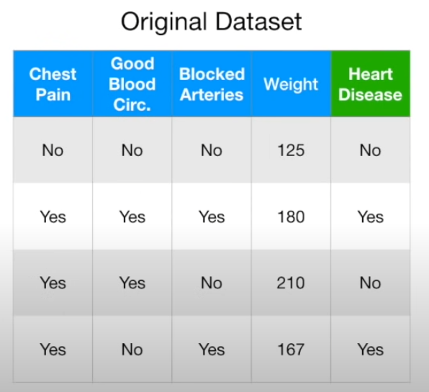

In order to build a random forest at first we need to create the bootstrapped dataset. In order to do that we are randomly selecting rows from the original dataset. We can select the same row multiple times and we are not selecting all the rows.

So for example in our bootstrapped dataset we can have rows number 1, 2 and 4 from the original dataset, row number 4 will be selected 2 times and row number 3 will not be selected. We can use row number 3 for testing a model. Our bootstrapped dataset will look like this:
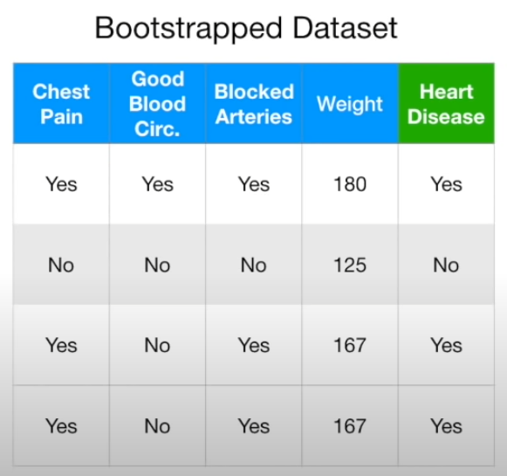

Now we need to build the first decision tree. We do this just like with a normal decision tree with one exception. For each node, in order to decide what column will be used in that node for splitting a dataset we are considering only a randomly selected subset of columns.

For example for the root node we choose the best column out of those two columns:
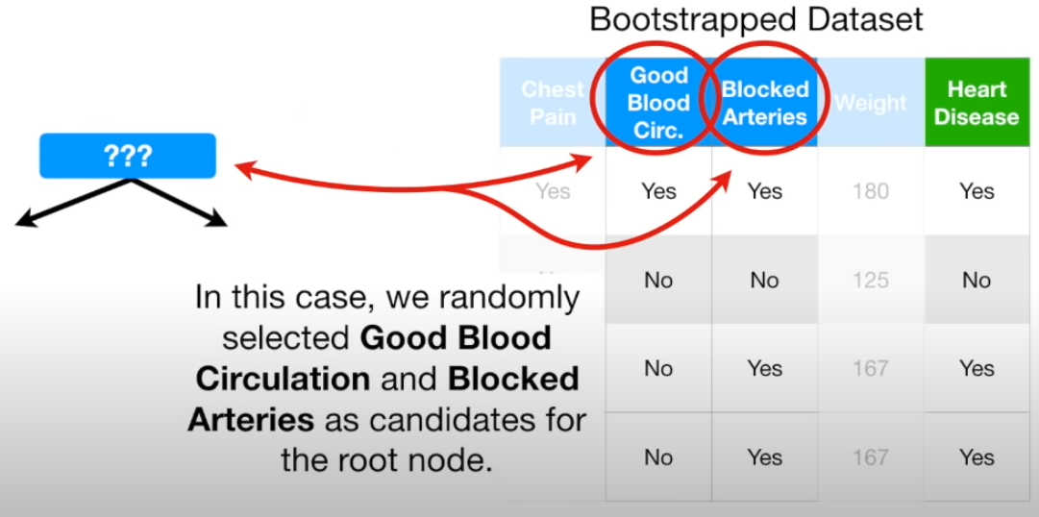

Let’s assume that for the root node we have choosen the ‘good blood circ.’ column. For the next node we are randomly selecting again two columns but we are considering only the remaining columns, without the ‘good blood circ’:
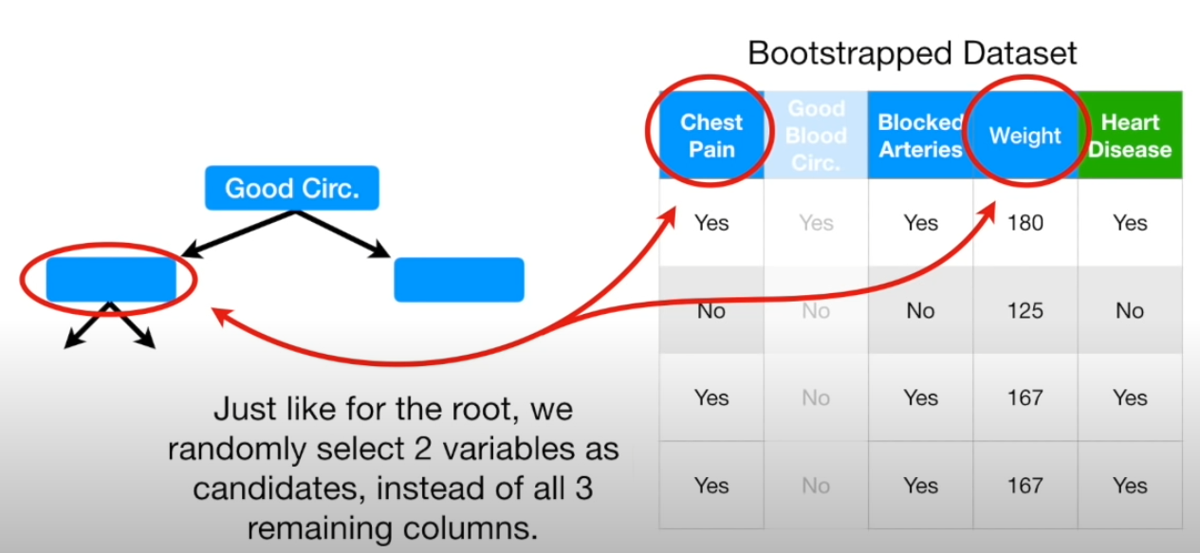

In this example we were choosing randomly two columns for each node but we can choose a different number. This is a hyper parameter which we need to choose.

In this way we have built one tree. Now we are building additional trees with different bootstrapped dataset and we will be selecting different subsets of columns for each node (because we are selecting them randomly).

Once we have build multiple trees and we want to make predictions, then each tree is making a prediction and we check which class is the most popular among those predictions.

Clustering
In order to perform clustering using a random forest we create a proximity matrix. Let’s assume that this is our dataset:
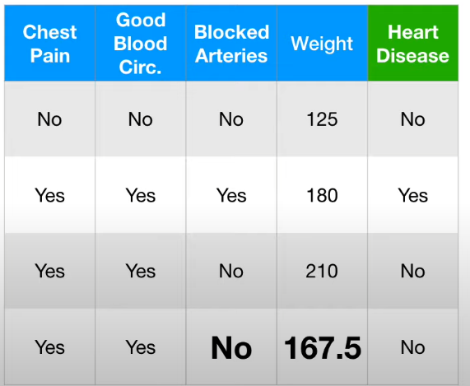

For each sample in a dataset we create a column and a row:
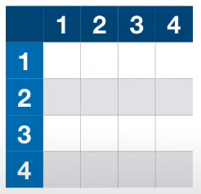

Now we take one tree from a random forest and we check which samples belongs to the same leaf. Let’s assume that only samples 3 and 4 belongs to the same leaf. We will note that in our proximity matrix:
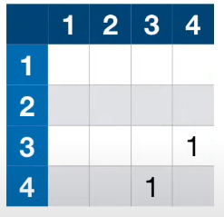

Now we do the same for the other trees. If for example in the second tree we also see that samples 3 and 4 ends up in the same leaf we add ones to our proximity matrix:
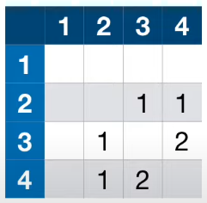

At the end we divide all values in the proximity matrix by a number of trees:
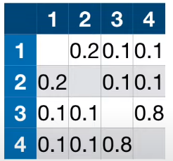

So in each cell we have a value between 0 and 1. The value in a cell in the i-th row and the j-th column indicates how similar are the i-th and the j-th samples. The higher this value is, the more similar are corresponding samples.

n_estimators argument for random forest

It’s number of trees used. The bigger that value is the more accurate model is but also more complex so there is more calculations.

max_samples argument for random forest

It determines what fraction of the original dataset is given to any individual tree.

max_samples argument for random forest

It determines maximum number of features provided to each tree in a random forest.

Random_state argument

It determines how we shuffle a dataset, if random_state = none then each time when we shuffle dataset this value is random and different, and we shuffle a dataset in a different way. When we set random_state equals to some integer then each time we shuffle dataset it will be shuffled in the same way. For different values of random_state a dataset is shuffled in a different way.

